✅ YD-448CCM Mid-Security Office Shredder

🆕 Dual-Feed Shredder with Large Bin – Built for Office Efficiency & Security
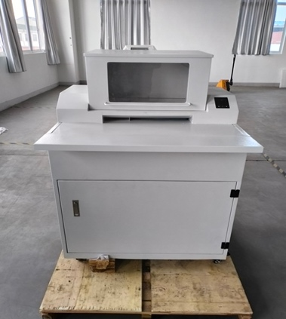 | 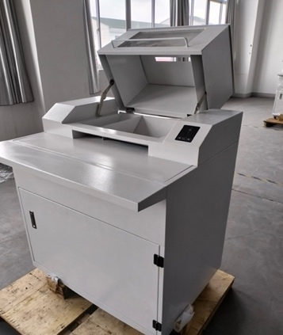 | 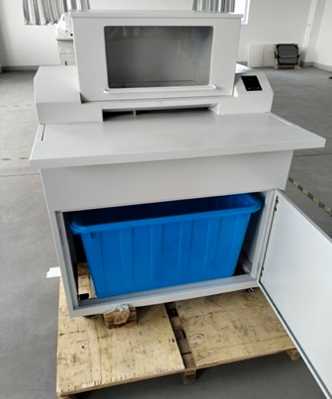 | 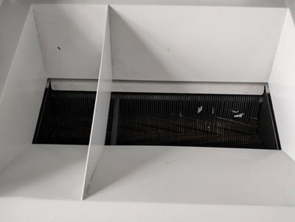
Front View | Right Side View | Safe Feeding Inlet | Fully Enclosed Waste Bin

✨ Highlights：
🔹 Dual Input Design  - Top Cover Inlet: for bulk-bound reports & thick documents  - Front Slot Inlet: for everyday papers and A4 sheets  🔹 Micro-Cut Security (2×15mm)  - Shreds 40–60 sheets per pass  - Meets EU P-5 to P-6 security levels  - Suitable for financial, legal, and classified document disposal | 🔹 Powerful + Quiet  - 2.2KW motor supports continuous 3+ hours operation  - Quiet at only 55dB – ideal for shared office environments  🔹 160L Extra-Large Bin  - Easy-open front cabinet for fast emptying  🔹 Optimized for Offices  - Ideal for government departments, accounting teams, and secure workspaces
🌍 Preferred by Industry Leaders
🔧 Technical Specifications:
Model | YD-448CC | YD-448CCM
Inlet Width | 30mm | 310mm
Shred Size | 3.9*45mm | 1.9*15mm
Sheet Capacity | 50-70 (70g, A4) | 40-60 (70g, A4)
Shredding Speed | 3.5m/min | 3.5 m/min
Noise Level | 55dB | 55dB
Net Weight | 258kg | 258kg
Rated Power | 2.2KW | 2.2KW
Continuous Operation | 3+ hours | 3+ hours
Dimensions | 1322*877*790mm | 1322*877*790mm
Bin Capacity | 160L | 160L
Pricing RMB | ¥68971 | ¥83975
Pricing USD | $9,715 | $11,828
